**East Quogue Community PTA**

**6 Central Avenue**

**East Quogue, NY 11942**

**March 12, 2024**

**General Meeting**

In attendance:

PTA Board: Bria Spanbock, Jessica Schwinn, Katie Back, Briana Gladding, Cait Horstman, Tahlia Kouffman

PTA Members: Cindy Cagno, Laura Calandra, Jessica Ferreira, Jenny Fiore, Luz Garcon, Amanda Moran

Administration and Staff: Danielle Davin

Call to Order:

Bria Spanbock Time: 9:26am

*Meeting was held via Zoom*

Acceptance of Minutes:

1st Katie Back

2nd Tahlia Kouffman

BOE Meeting Update: Briana Gladding

* BOE meeting is next week
* BOE members are attending WHB BOE Meetings
* Owens Award 5/21

Teachers Report: Danielle Davin

**Kindergarten**

In April, Kindergarteners will be learning about the characters, setting, and plots in the books we are reading. We will also be finishing up our how to books! In math, we are learning about 2D and 3D shapes. We will also learn about plant parts and life cycles, the Earth and how we can be kind to the Earth.

**1st grade**

In writing workshop, the first grader authors are busy writing nonfiction All About Books.  The children are writing books to teach others about topics that they are experts in.  The talented writers are including diagrams, glossaries and a question & answer section in their books

In math, the students have started a new math unit.  The children will be  adding  two digit numbers. The students will learn different strategies to help them add two digit numbers  like drawing a picture and making a ten. Science/Social Studies - The children were very excited for their in house field trip- StarLab.  The portable planetarium allowed students to experience the night sky indoors.  The children were able to tour the stars and constellations that they have been learning about in the classroom.  The first grade astronomers are continuing their unit on the Solar System by exploring the planets. The students will be celebrating Earth Day. The children will learn about the importance of protecting our planet and will participate in various activities around the day.

**2nd grade** Students will be celebrating the joy and expressiveness of Poetry in tribute to Poetry Month. In math, students are diving deeper in measurement with word problems using different types of measurement units. Second graders continue to divulge into all different genres of fiction and in writing they are writing realistic fiction stories, focusing on plot. Social Studies, they will learn about “What Makes a Hero”. The second grade classes are excited for the upcoming solar eclipse and celebrating Earth Day with a recycled bug project.

**3rd grade** Students in third grade are so excited for the start of spring! We are learning about the government in our own country, and comparing it to the governments of countries around the world. In math we are measuring, reading and creating graphs, and reviewing all of the new concepts we have learned this year. Third graders are enjoying both fiction and non-fiction texts and applying the reading skills we have learned to aid in comprehension. We are comparing and contrasting fiction texts, specifically focusing on plot, characters, and theme. In writing, we are responding to texts using text evidence. Students also continue to practice their cursive handwriting. It’s a busy, but exciting time of year!

**4th grade** Fourth grade students have been working hard in math as we are learning geometry!  Students are studying symmetry, classifying triangles by sides and angles as well as identifying quadrilaterals.  In ELA, we wrapped up persuasive writing, and have now been working on expanding our writing with text evidence.  In Social Studies, we are beginning to learn about the fascinating events that led up to the American Revolution, and the strain between the colonists and the British.

**5th grade -** Fifth grade has had another exciting month! In Math we completed our study of volume and are working on converting and displaying units of measurement. During ELA, we are continuing to work on utilizing text-based evidence to answer higher level questions as we prepare for 6th grade writing. During Book Club, the fifth graders are finishing Restart by Gordon Korman and will soon be engaged in a creative project to share their understanding of this fantastic novel. We are looking forward to the upcoming Science Fair. On April 18th, the fifth graders will all present their experimental findings during class time. We are excited to give them this opportunity to share their hard work with their peers.

**6th grade -** In 6th grade Math, we are learning about integers, comparing and ordering integers and absolute value.  We are graphing ordered pairs on all four quadrants of the coordinate plane and writing, graphing and solving inequalities. In Science we have started Mrs. Alessi’s favorite chapter, The Periodic Table! We are currently working on our Atomic Theory Timeline projects.  In ELA we are learning about and practicing the art of debate and learning why it is so important to back up your point of view with evidence. We learned about rhetorical appeals such as logos, pathos and ethos. This does not give them the right to argue with you at home!

**Music:**

-Third grade students are working very hard to earn their recorder karate belts and prepare for the upcoming concert.

-Our marimba group has selected their theme for their June performance and are going to begin that soon.

-Both Junior and Senior Choruses are preparing for their May concerts.

-K-2 has just finished up learning various spring songs and will be jumping into learning songs and games from all over the world.

-Grade 4 is working on composing musical pieces.

-Our vocal NYSSMA students are working on their solos and sight-singing for their upcoming Festival on May 2nd.

**-** Our Instrumental NYSSMA students are rehearsing their Level 1 and Level 2 songs and scales in preparation for their upcoming Festival in Southampton on May 2nd.

- Our Marching Band has been working on their performance in the East Quogue Memorial Day Parade on May 26th; this will be the beginning students’ first parade performance since the Hampton Bays St. Patrick’s Day parade was canceled.

- The students in Beginning Band have been rehearsing and learning how to fully play and perform concert music together, in preparation for their very first performance on Tuesday, May 21, 2024. Their concert begins at 6pm, and is followed by a Board of Education meeting in the cafetorium.

- Our Jazz Band has been quietly rehearsing and planning their “debut” comeback concert performance on Wednesday, May 15th. This very special concert performance begins at 6pm and starts off with our impressive Advanced Concert Band, followed by our very talented Senior Chorus, and ends with our long awaited and highly anticipated return of the East Quogue Jazz Band. We are all so excited to FINALLY be back to concert performances with our Advanced Band and Senior chorus, after having been on hold since the 2020 COVID shut-down.

**Art**

2ND-5TH GRADE ARE VOTING ON THE AGENDA BOOK COVERS CREATED BY THE 4TH AND 5TH GRADERS TO DECIDE WHICH ARTWORK WILL GO ON THE COVER NEXT YEAR. ALL GRADE LEVELS ARE WORKING ON SELF PORTRAITS.

**Kindergarten and first** grade are learning about the parts of the face and what details we need to include in a self portrait in order to make it look like us! They are also learning about foregrounds and backgrounds and practicing scissor skills by creating a background, cutting their portrait out, and gluing it.

**2nd and 3rd** Learning about how we can represent how we look physically in our self portraits, but also how we can reveal things about our personalities in our self portraits. Including expression, using color as symbolism, and collaging in pictures of things we like

**4th and 5th graders are working on** high contrast self portraits. Using the element of art, line, in their self portraits to contrast backgrounds where they are using a watercolor technique called wet on wet. Students are using black ink to draw all the details in their portraits and contrasting that with a colorful background.

**6th** Continuing to learn about facial proportions and the anatomy of the face. Practicing drawing and shading the parts of the face to complete their self portraits. Using the greyscale with graphite to show shape and dimension in or faces.

**April In Spanish class, the students are currently :**

**6th grade** Manipulating sentences by replacing names with subject pronouns.

**5th grade**: Asking fellow classmates who complete household chores in their homes .

**4th grade**: Determining the capitals of all Spanish speaking countries.

**3rd grade:** Examining and complimenting classmate’s clothing.

**2nd grade:** Discussing popular foods of Spanish speaking countries.

**1st grade:** Locating, connecting, naming a variety of farm animals.

**Kinder:** Identifying 9 colors.

**Garden/Greenhouse**

Spring is finally here and planting in the garden is in full swing! We’ve planted our lettuce seedlings, radishes and sugar snap peas**.** On the weekend of March 23rd Christian Capolino and members of his Boy Scout troop came to complete Christian’s Eagle Scout project.  After months of planning they installed benches constructed by them into the garden, weeded, spread mulch, planted a new flower box and hung a sign at our garden entrance! Thank you so much to Christian and his troop for all their hard work.  2nd grade Earth Rangers starts this week, be on the lookout for information about 3rd/4th grade Earth Rangers at the end of the month! Happy growing!

**STEAM**

K-1 Students are beginning a unit on bird nests. They will learn about shelter, structure, balance, and intersecting lines!

Second grade students are researching an insect of their choice and will be introduced to TinkerCAD to create 3D Models of their chosen insect.

Third grade students are talking about balanced and unbalanced forces and engineering paper marble roller coasters.

Fourth graders are finishing their Erosion and Weathering Stop Motion animations.

Fifth grade students are beginning their “Battlebots” mini project where they will create a “battle shell” for our robot, Sphero. Students will “battle” their shells by programming Sphero to move randomly in the ring and hoping they knock over their competitors shells.

Sixth grade students are beginning their Sphero Chariot unit. Each student will build a chariot that utilizes our Sphero robots as a “horse” and program the robot to travel around the “Circus Maximus” (our rug!) in the STEAM Lab.

**PE**

The last few weeks students have participated in different  parachute activities and games. Upper grades started completing their fitness testing.  All classes worked in fitness stations that included battle ropes, jump ropes, juggle cubes, etc.  Some students also tried out hacky sacking individually and with a partner.  Student teacher Mr. Fabian brought in some fun games such as Dragon Tails, Rock Paper Scissor Tag, Scramble, etc.

Treasurer’s Report: Katie Back

* Most of our funds have been allocated or earmarked for the year! About 10K held to pay for September 2024 PTA events



We are focused on streamlining the requisition process for next year and have agreed the following parameters:

* This is the guidance that the PTA has given in its requisition form process: Embracing an ethos (i) to focus on augmenting educational programming through specials areas (defined as Arts, STEAM, Foreign Language, Reading, Library, Music etc) and (ii) to reaching as many students as possible in that effort
* The PTA will seek to amend this ethos next year by adding additional expectations on: (iii) keeping experiences onsite at East Quogue Elementary (as opposed to external experiences); (iv) including both a teacher sponsor and a specials sponsor for any event; (v) not accepting single-grade focused requests(unless there is strong rationale); and (vi) continuously challenging ourselves to uphold these guidelines

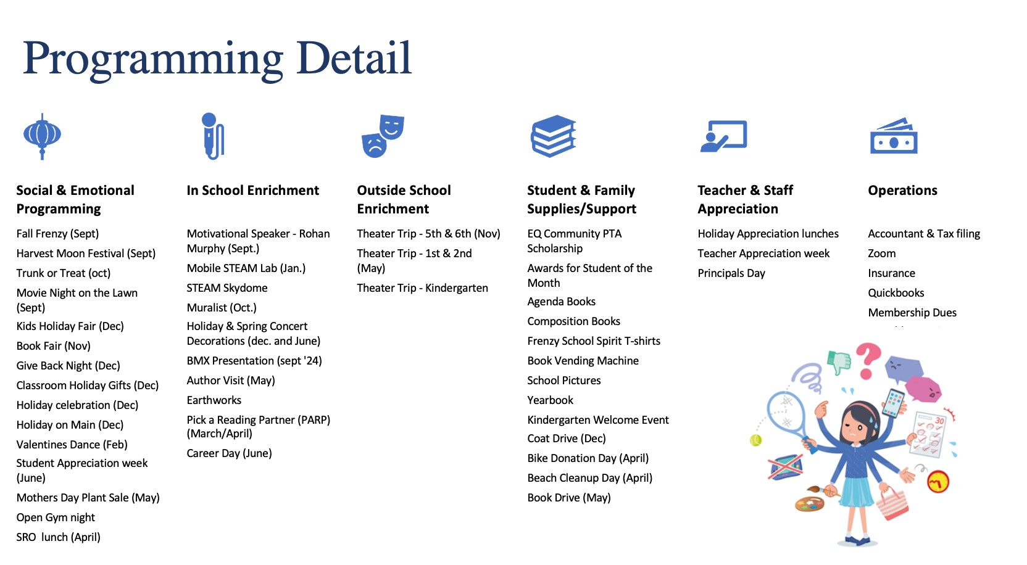

President’s Report: Bria Spanbock

*Old Business:*

* Relay for Life – run by Mr. Purkis and Mrs. Alessi, sponsored by the Student Council. This is to raise $ for survivors of cancer. Events include:
  1. Coin Wars (3/1) during lunch times
  2. Pasta Dinner (3/13) from 5:30-7:30pm
  3. Dance (3/20): k-2 from 5-6pm and 3-6 from 630-730pm
  4. Trivia Night (4/12) from 6-8pm
  5. Relay for Life (5/3) from 6-11pm
* Pick a Reading Partner (PARP) – was a success! Congratulations to Mrs. Culhane, Ms. Bonner and Mrs. Wyllie’s classrooms as our top three finishers. We can’t wait to see Mr. Miller dressed as the Culhane’s storybook character!
* “Raise a Glass for Rob” (3/14) – 10K raised this year!
* 3/27 Pizza party lunch with the SROs – PTA supplied small prizes and brownies

*New Business:*

* Giveback Bike Rodeo – will take place this weekend (April 12/13th ). Bring your gently used bicycles and scooters on Friday and trade / pick up a bicycle scooter on Saturday. Thanks to the police department in advance for setting up a bike course and teaching bike safety!
* Giveback Beach Cleanup – 4/28 3-4pm at Hot Dog Beach. PTA is supplying grabbers and gloves. This is part of the Great East End Cleanup sponsored by the Town of Southampton.
* Career Day – dated TBD – 5th and 6th grades
* Mother’s day plant sale - orders due April 17th . Pick up on 5/8 and kids shop on 5/9 and 5/10
* Author Visit – Bruce Hale – 5/16. Book order forms are in! Extra copies available in the school library.
* Bookfair and drive schedule for May – more to come
* EQ PTA Scholarship – essays received and distributed to committee readers. Decisions will be made by the end of the month.
* PTA board Elections – 5/14
* Principals Day – May 1st
* Teacher Appreciation Week – May 6-10

- Monday 5/6 – Decorated classroom doors

- Tuesday 5/7 – Coffee truck @ school

- Wednesday 5/8 – Potluck Lunch (parent signups to be sent out by PTA soon)

- Thursday 5/9 – Succulent Gifts

- Friday 5/10 – Massage Day

* Staff Breakfast – 5/17
* Are you smarter than a 6th grader? To be put on by SRO
* Spring Concert 5/16
* K Screening – 5/13-15
* K Orientation – 6/6
* Field Day
  1. K-3rd - 5/29
  2. 4-6th – 6/5
* 6th grade graduation: 6/18
* K graduation: 6/12

Next PTA Meeting: May 14th at 915am

Next BOE Meeting: April 16th at 7pm

Motion to Close:

Tahlia Kouffman

Jessica Schwinn